**Dengue Disease Detection**

T.Niranjan Babu1, B.Hari Chandana2, Patil Lakshminarayanamma3, Sana Babu Reddy4

1Assistant Professor, 234Student

*JNTUA College of Engineering (AUTONOMOUS):Pulivendula*

*Department of Computer Science & Engineering*

*tniranjanbabu@gmail.com,manikayyachandana99@gmail.com2,lakshmi10.patil@gmail.com3,sanababureddy@gmail.com4*

**Abstract:** Dengue is the most dangerous disease that is caused by the bite of mosquito called Aedes aeghpt. Several researches said that there were approximately 390 million dengue infections per year and it is considered as a major health issue in Asia-Pacific and American regions[2]. It is a life-threatening disease and the number of people died due to dengue disease because its symptoms are not detected at the early stages many people thought that it was a normal fever so that they ignore it which cause leads to dangerous situations and worst case they lose their life. Dengue occurs in followed by two stages: Dengue Fever(DF), Dengue Haemorrhagic Fever(DHF). Early detection of the dengue disease which helps to control and used to give the treatment to patient and reduce the risk of life of patient. For that symptoms of patient will be compared with previous cases of dengue to check the patient as infected or not. In this paper, we take the data from different hospitals and examine the dengue cases with different machine leaning algorithms. The algorithm which gives best results with more accuracy is found out for the detection of dengue disease.

**Key Words:** Machine learning - Detection –Dengue Fever – Dengue Haemorrhagic Fever – Symptoms – White blood cells

1. **INTRODUCTION**

Dengue is a major dangerous disease and mostly observed in American and Asia-Pacific regions.World Health Organization(WHO) said that around 50-100 million people had been affectedby dengue disease every year worldwide. It is caused by a mosquito-bitten of Aedes aegypt. It is also occur when a person bitten by a mosquito which bites a dengue infected person. The disease has an incubation period of 3 to 15 days and begins with flu-like symptoms. In most cases, the disease lasts about 3 to 10 days, but some symptoms and signs may remain and take a long time to disappear. Dengue occurs in two stages:

* Dengue Fever(DF)
* Dengue HaemorrhagicFever(DHC)

In the dengue fever stage, there will be high fever, body pains, joint pains, vomitings, fatigue, stomach ache and skin rashes. This stage will last for six to seven days. But in some cases, the disease leads to the most dangerous life-threatening dengue haemorrhagic fever is very dangerous with combination of dengue fever symptoms. There is a sudden rise in temperature nearly 1050F with convulsions and other flu-like symptoms.There will be a huge reduction in white blood cells. In moderate cases of Dengue Haemorrhagic Fever, all symptoms will be reduced with the relief from fever. In advance cases, the dengue infected person health condition turns to a worst with the drops in temperature, with blood vomiting symptoms and the patient frequently affected with shock state. We observe small spots of blood on the body skin of patient. It also causes nose bleeding.. A deadly combination with shock may cause death with in one day. The symptoms for Dengue Haemorrhagic Fever are severe pain in the abdomen, severe joint pains, blood vomitings, bleeding from nose, gums, mouth along with the symptoms of dengue fever. This symptoms will be used for the detection of dengue disease. First of all, we will identify the symptoms of dengue inpatient and the prediction takes place with the identification of symptoms.Classification is done by using datasets and to predict accuracy.

1. **LITERATURE SURVEY**

In all the existing system models there are some drawbacks in those systems. So, we can come with an idea to reduce those drawbacks in the detection of dengue disease.

[1] In this paper, they examine with different machine learning algorithms and evaluate the accuracy of those algorithms. In this they implement Data mining for the detection of disease like dengue. In this they take the Weka tool box is used to findout to get the output.

[2] In this paper, the system proposed as the blood images are captured by a digital microscope. In preprocessing, noise is present in images so this noise can be removed by median filter. In this, they compare the white blood cells nucleus with the help of SIFT algorithm. With SVM classifier algorithm they find out as infected or non-infected.

[3] In this paper, the dengue disease is detected by weather forecasting. The dataset contains attributes like temperature, rainfall, humidity, precipitation,etc.. They are done with Mean Square Error(MSE) and Gradient Boosting Regression(GBR).

[4] In this paper, they develop two sets of Random Forest models for the national and department levels in Colombia to predict weekly dengue cases at 12-weeks ahead. A national model based on artificial neural networks(ANN) was also developed and used as a comparator to the Random Forest. The various predictors included historic dengue cases, satellite-derived estimates for vegetation, precipitation, air temperature, and population counts. This study showed the potential of Random Forest in dengue forecasting with also demonstrating the feasibility of using a national model to forecast.

[5] In this paper, they also find out neurological and clinical implications that leads to a fatal disorders that occur by dengue disease. In this, they mainly focus with the consequences that used to face by a dengue affected person.

1. **LACUNA IN EXISTING SYSTEM**

There will be an existing system for dengue detection based on weather forecasting. The system is like with attributes temperature, rainfall, humidity is the major attributes for the mosquitoes to flourish. So, they take the attributesTemperature, population, Precipitations, Urbanization, Temperatures to detect the dengue disease. It gives the result only according to the area weather conditions.But the dengue disease can’t be decided upon weather condition but the dengue disease will be detected based upon symptoms of dengue disease.

1. **METHODOLOGY**

In the proposed system, the detection of dengue disease is done by collecting different dengue cases from different hospitals. The data sets contain information about the number of dengue fever cases. It contains information about the symptoms of different dengue infected persons. The symptoms are fever, vomiting(with or without blood), nausea, body pains, pain behind eyes, joint pains, chill, headache, swollen glands, rashes, abdominal pain, bleeding nose, bleeding mouth, fatigue, red eyes, and platelets count. It includes dengue heamorrhagic fever, followed by high fever.

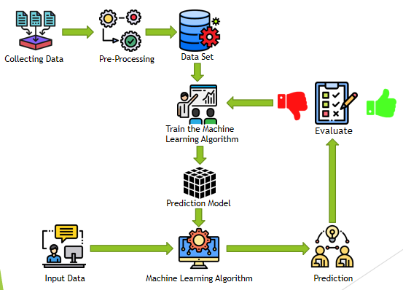

**Fig-1: Architecture**

First of all, collect the data from different hospitals.

* 1. **Pre-processing**

The dataset which we collect first must contain several different values of every attribute which leads to improper learning. For better learning we have to preprocess the data. Therefore, the information must be preprocess by the learning model.

The pre-process includes the following:

The data set contain a lot of unentry data values. These unentry data values results in in-accuracy ,these can be handled by the following ways:

1)Entering the unentry values: The unentry values in the dataset must be filled with the most occurring data values in the data set for the attribute.

2)Deleting the rows: The rows which consists of unentry data for any attribute must be removed. By this, we delete the unimportant data from the dataset. So, by this technique, the number of data instances must be reduced. Hence this method can be implemented for large datasets.

**Conversion to numerical values:**

The attributes that contain string values need to convert into numerical values. In the dataset, the attribute body pains have high, mild, low values. This can be converted into numerical data by using get method by assigning low=0, mild=1, high=2.

**Data Cleaning:**

In the dataset, there can be some attributes that don’t affect the output. That attributes need to be find out and can be dropped from the dataset to reduce the dataset.

In our dataset, the id is the redundant attribute. Hence the attribute id was dropped.

* 1. **Implementation – Prediction:**

In the prediction process, we get the output by giving all the values of symptoms. Given below is the sample dataset.

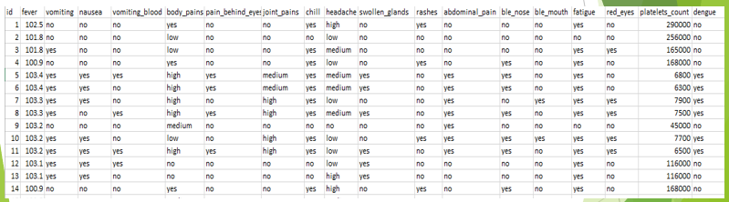

**Fig-2: Data set**

**Algorithm:**

We impement dengue disease detection Model, with the help of two algorithms and they are:

* Decision Tree
* Random Forest

The ensemble method of approach of decision tree is called Random Forest. A decision tree is consists of a many internal nodes and each internal node corresponds to each attribute, every branch gives the result, every leaf holds a class label. Random Forest requires training each decision tree with a random pick up subsample of the whole datasets.

* 1. **UI**

We design UI for the dengue detection it takes all the symptoms and gives the output.

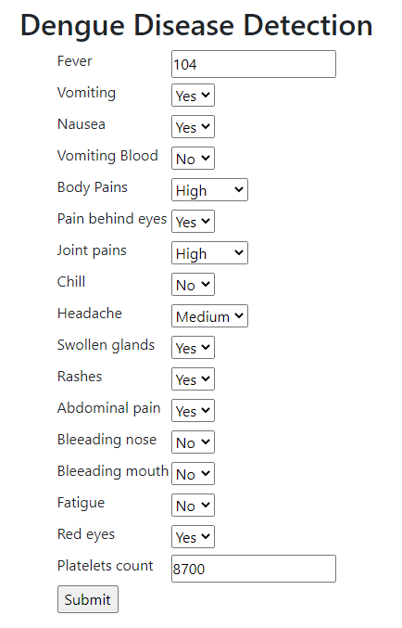

**Fig-3: UI**

1. **RESULT AND ANALYSIS:**

We compare the various algorithms and with the algorithms Decision tree and Random Forest, we get more accuracy. With the help of historical data, we get the result if the patient is infected or not. If the symptoms of the patient are given to the UI it takes the values and in the background, it will analyze all the dengue cases and gives the output if the patient is affected with dengue disease or not.

We will take one dengue affected and dengue unaffected case.



**Fig-4: Dengue affected case**



**Fig-5:Dengue unaffected case**

So, by giving all the symptoms of the patient it gives the result.

1. **CONCLUSION**

The proposed system is based on the symptoms of dengue disease and it is used to avoid the mistakes or errors of lab technicians. In this, the sequence takes place as pre-processing, train the algorithm, prediction, evaluation. In this by taking historical dengue cases to predict to detect the infected or non infected using Random Forest and Decision tree.

1. **REFERENCES**

[1]N.Rajathi, S.Kanagaraj, R.Brahmanambika, K.Manjubarkavi “Early Detection of Dengue Using Machine Learning Algorithms,” International Research Journal of Engineering and Technology(IRJET) Volume 118

[2] Reenu Marie Philip, Gopakumar “Automated Dengue Detection,” International Research Journal of Engineering and Technology(IRJET) Volume: 05

[3] P.Muhilthini, B.S.Meenakshi, S.L.Lekha, S.T.Santhanalakshmi “Dengue Possibility Forecasting Model using Machine Learning Algorithms,” International Research Journal of Engineering and Technology(IRJET)

[4] Anna L.Buczak, Benjamin Baugher, Linda J.Moniz, Thomas Bagley, Babin, Erhan Guven “Ensemble method for dengue prediction,” PLoS One. 2018; 13(1): e0189988

[5] Rosmari Rodriguez-Roche, Ernest A.Gould, ”Understanding the Dengue Viruses and Progress towards Their Control,” BioMed Research International Volume 2013

[6] Sheng-Fuu Lin, Yu-Bi Hong, ”Differential Count of White Blood Cell in Noisy Normal Blood Smear”,IEEE2011.

[7] Joshi, Ms.Minai D.,Atul H.Karode, and Classification to Detect Acute Leukemia.” International Journal of Emerging Trends & Technology in Computer Science(IJETTCS) 2.3,pp.147-151,2013

[8] Ta-Chien Chan, Tsuey-Hwa Hu, Jing-Shiang Hwang,”Daily forecast of dengue fever incidents for urban villages in a city”,International Journal of Health Geographics,2015.

[9] Anshul Goyal, Rajni Mehta, “Performance Comparison of Naïve Bayes and J48 Classification Algorithms”, IJAER, Vol.7, No.11,2012.

[10] Katz,Alfred RJ. “Image Analysis and Supervised learning in the automated Differentiation of White Blood cells from Microscopic Images.”,2000.

[11] Ashwini Rejintal, Aswini N, “Image Processing Based Leukemia Cancer Cell Detection”, IEEE International Conference on Recent Trends In Electronics International Conference on ICT and Knowledge Engineering.